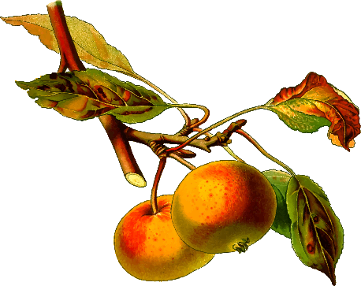
Photography Competition
& Exhibition

Categories
1/ Primary (K-2) 2/ Secondary 3/ Adult
(3-6)
Competition will be judged by local photographer prior to Tallong Apple Day with prizes given to Best Entry and Highly Commended in each category, People’s Choice, and Grand Champion on Tallong Apple Day. Winners will be notified prior to festival. Best Entry will receive a prize and ribbon. Grand Champion receives a camera pack. All entries are displayed on Tallong Apple Day.
All photographs to be submitted by 1st May 2019 to The Midge Tallong or email tallongappledayfestival@gmail.com to organise collection
All entries must be original and completed by exhibitor in previous 12 months.
All entries must be 6 x 4 sized with no frame on A5 black cardboard for mounting and display purposes.
A limit of 5 artworks per exhibitor is permitted.
Artworks must be collected after 3pm on Tallong Apple Day 5th May or by 12pm 6th May.
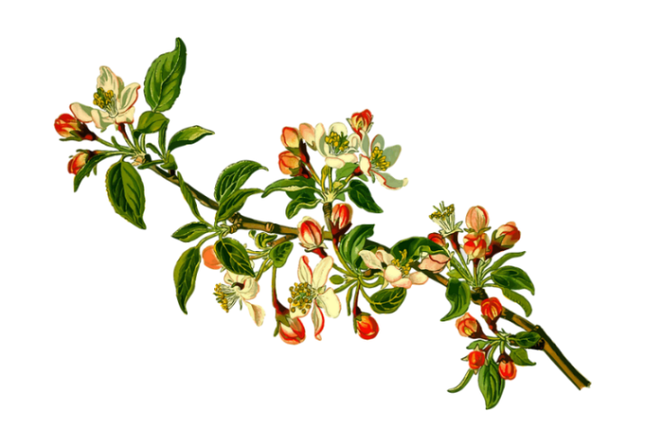
Join us in showcasing our local photographer’s skills. Come and view their photographs on display in the Tallong Memorial Hall on Tallong Apple Day 5th May 2019.
For more information, queries and entry forms please visit our website or contact us via email at tallongappledayfestival@gmail.com

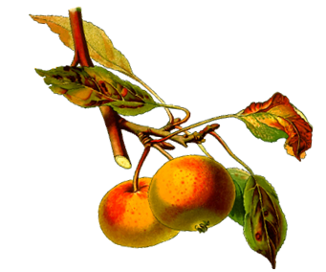
Photography Competition
& Exhibition

Categories
1/ Primary (K-2) 2/ Secondary 3/Adult
(3-6)
Competition will be judged by local photographer prior to Tallong Apple Day with prizes given to Best Entry and Highly Commended in each category, People’s Choice, and Grand Champion on Tallong Apple Day. Winners will be notified prior to festival. Best Entry will receive a prize and ribbon. Grand Champion receives a camera pack. All entries are displayed on Tallong Apple Day.
All photographs to be submitted by 1st May 2019 to The Midge Tallong or email tallongappledayfestival@gmail.com to organise collection
All entries must be original and completed by exhibitor in previous 12 months.
All entries must be 6 x 4 sized with no frame on A5 black cardboard for mounting and display purposes.
A limit of 5 artworks per exhibitor is permitted.
Artworks must be collected after 3pm on Tallong Apple Day 5th May or by 12pm 6th May.

Exhibitors Name: …………………………………………………………….…...
Contact Number: ……………………………………………………..…………...
Category (CIRCLE): Primary K-2 Primary 3-6 Secondary Adult
I hereby certify that the above exhibit is my bona fide work. I agree to abide by all decisions of the judges with regard to my entry. I will not hold the committee responsible for any loss or damage to exhibits through accident, mis-delivery or any other circumstances.
Signed: ………………………………………………………………… Date: ……………………………..
Office Use Only Entry Number: …………………………………………

