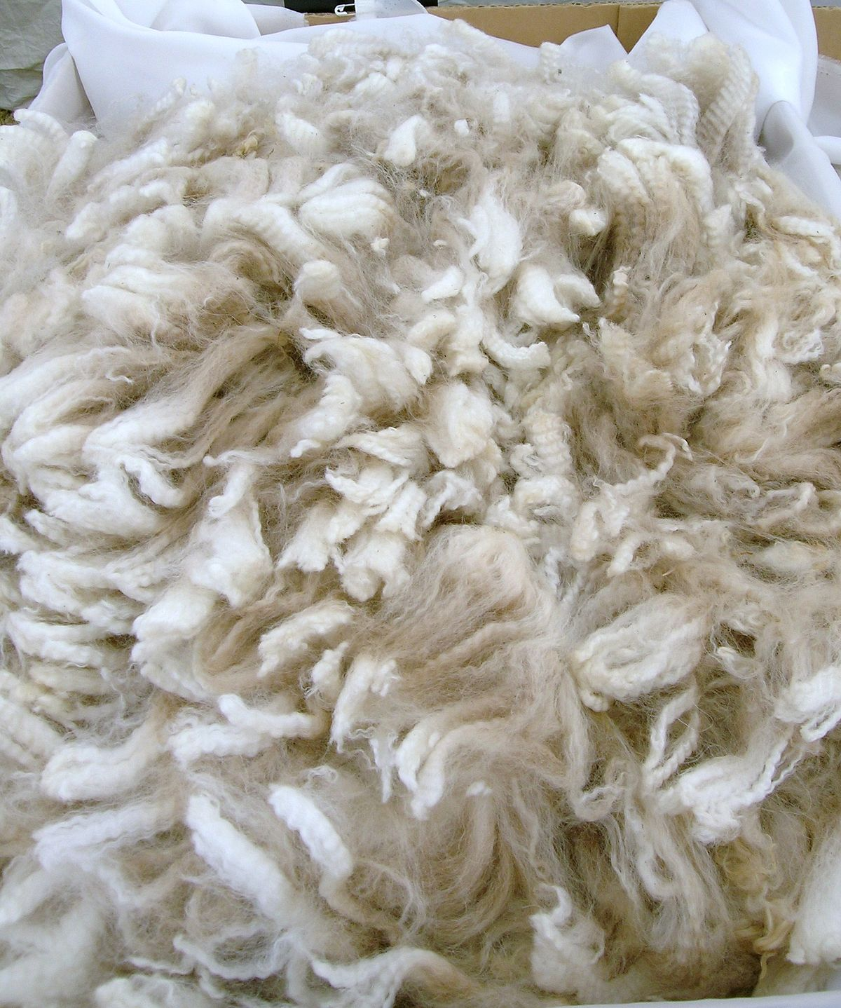
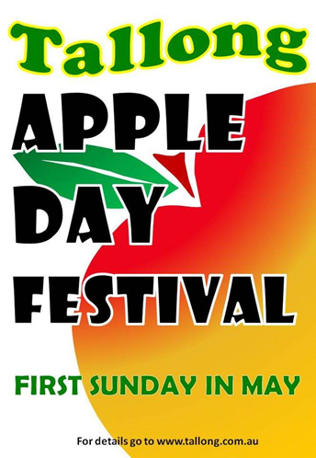
Fleece to Garment
Competition
Starts at 9.00am in the
Fleece to Garment Marquee
Come along and watch the spinner’s as they make their unique puppets!
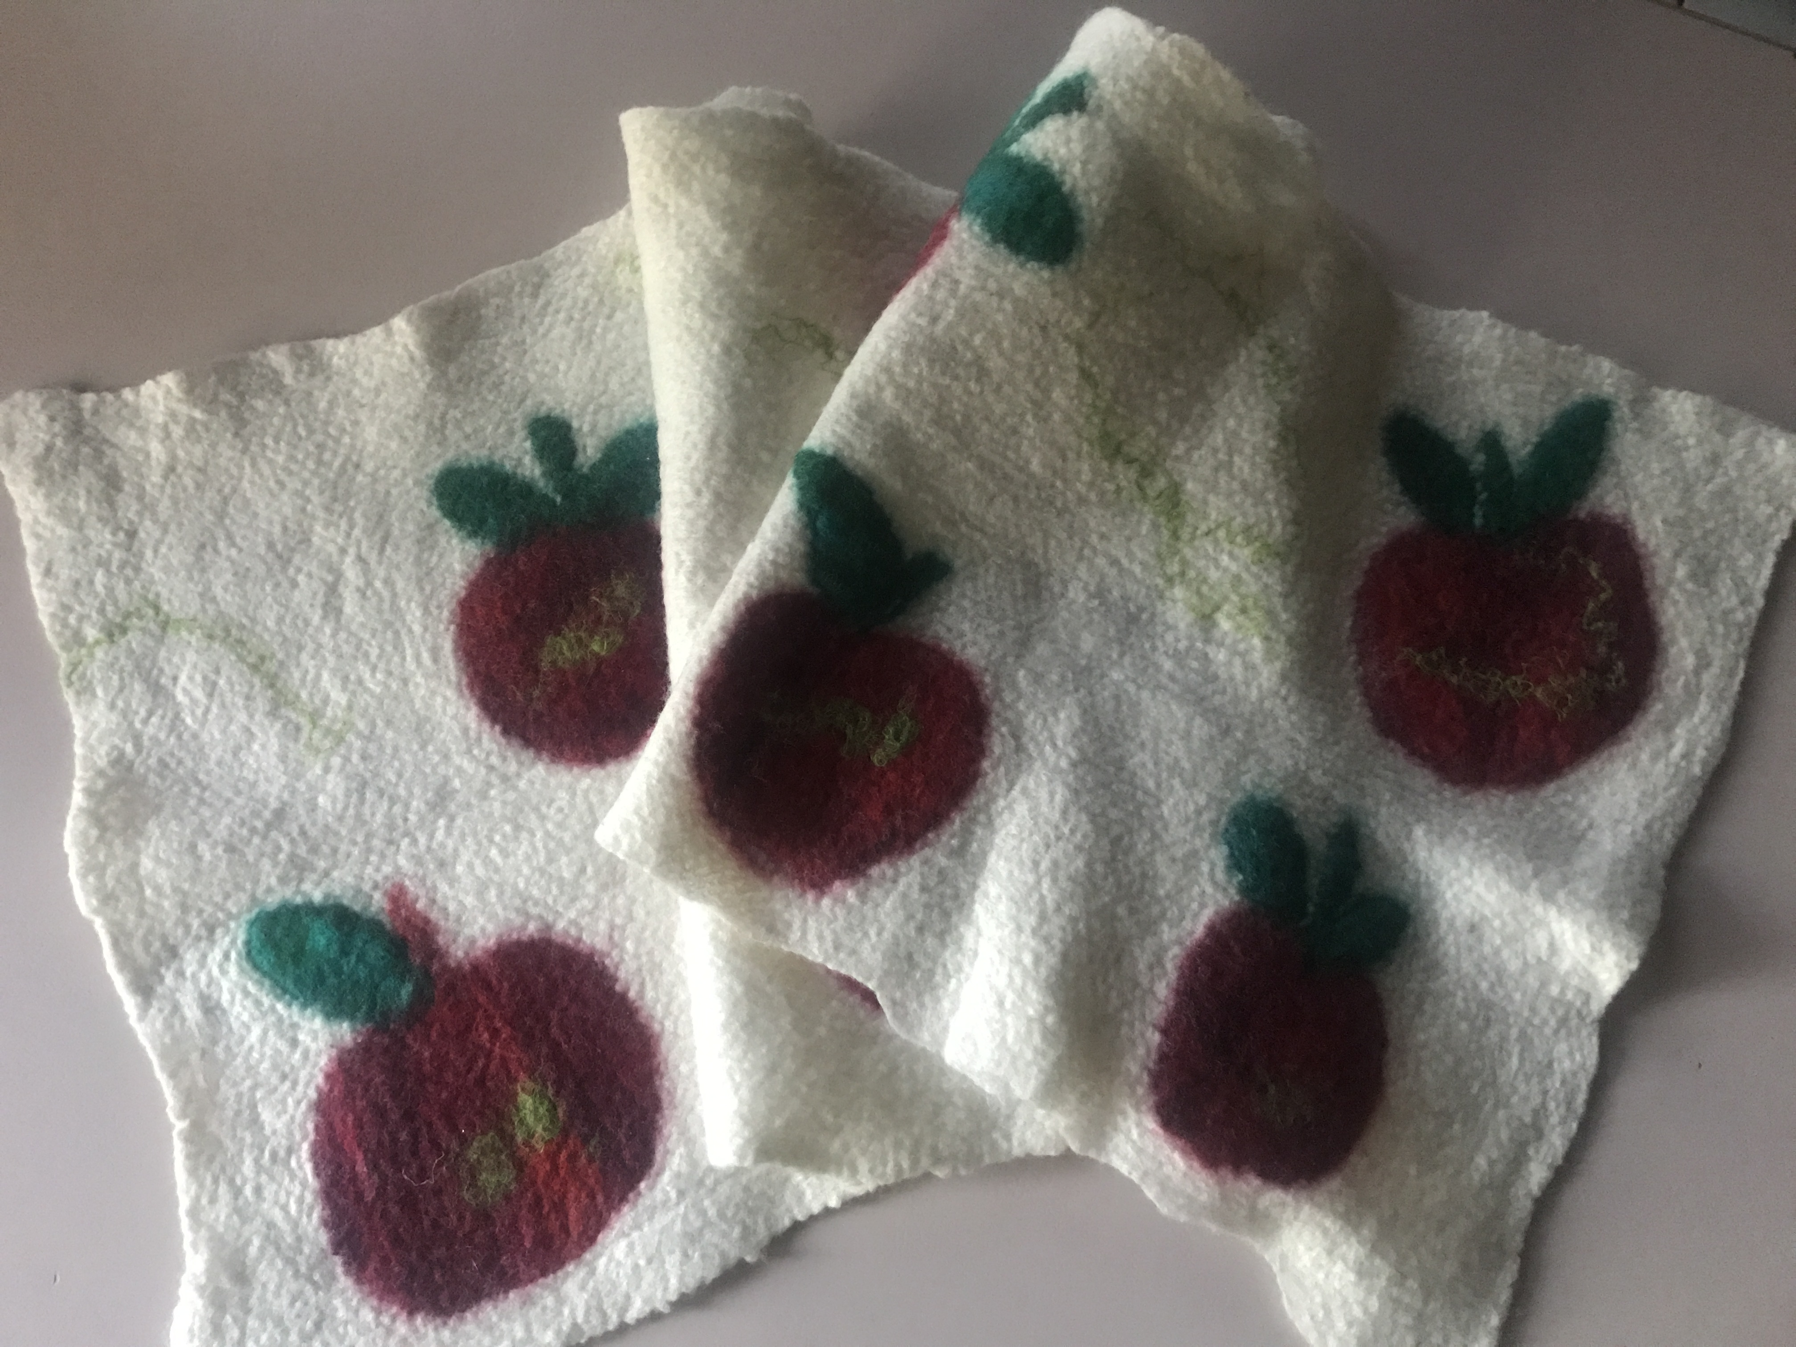
Be sure to see the Felter’s making an original Wall hanging- to be auctioned at 3pm
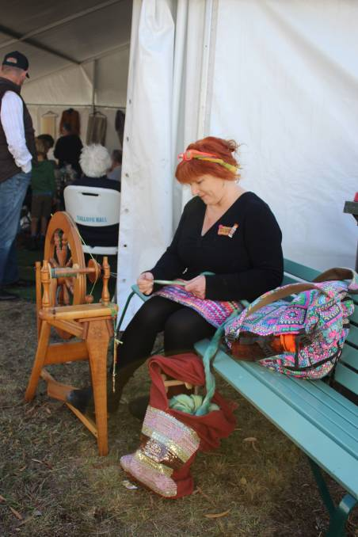
At 12pm on the main street the ladies all take their seat for the ever popular ‘Spin the Longest Thread’
To wrap up the competition join the teams as they introduce something new to Apple Day!
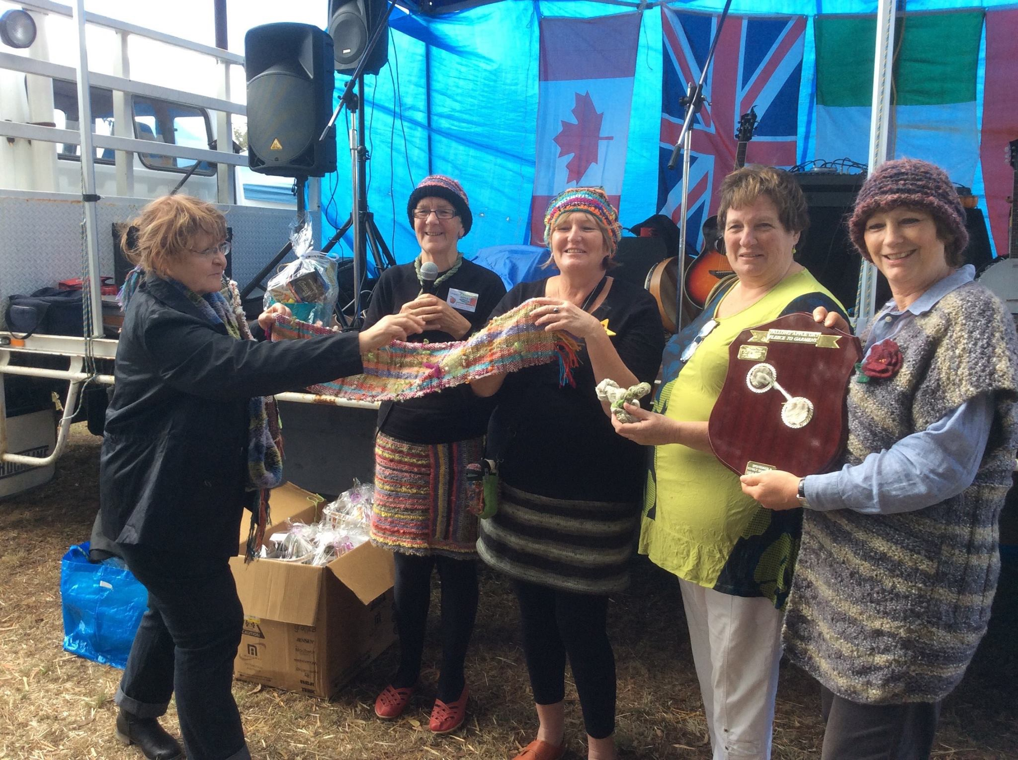
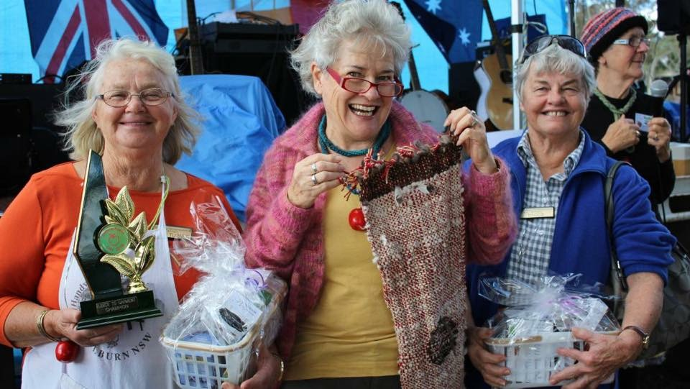
‘Witches Brew Mega Weave’
A group spinning activity around a Cauldron!
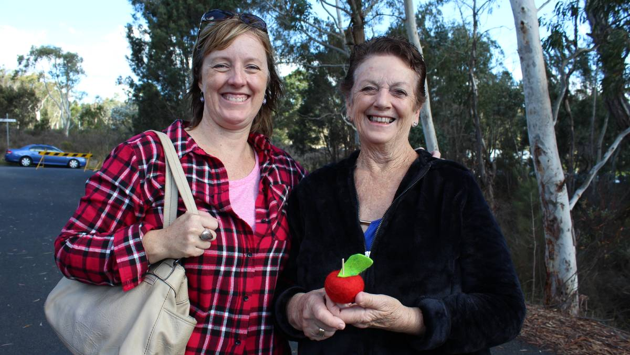
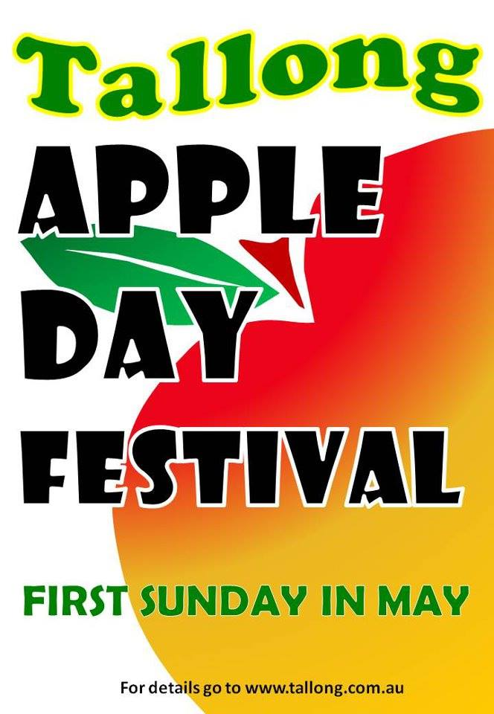
Lot’s of displays and items for sale inside Marquee
PLUS puppet making for the children all in the
FLEECE TO GARMENT MARQUEE IN THE PARK

