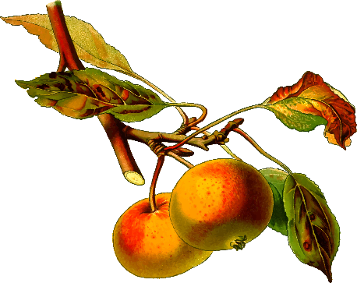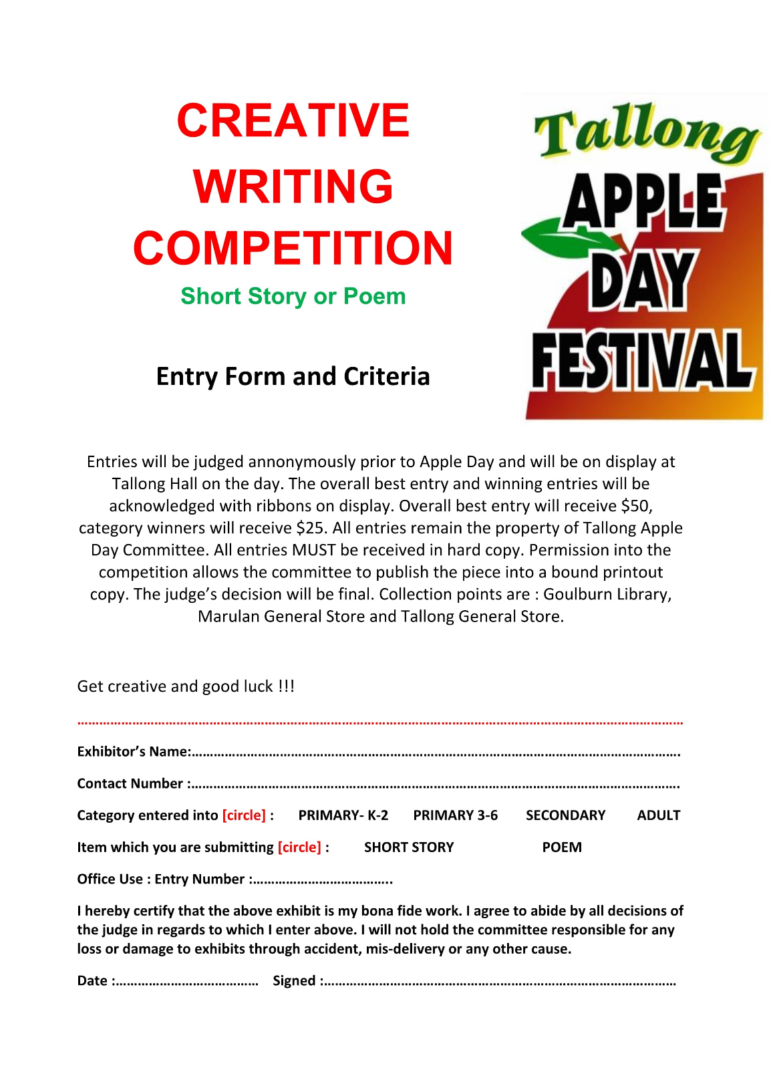

**Car & Bike Show**

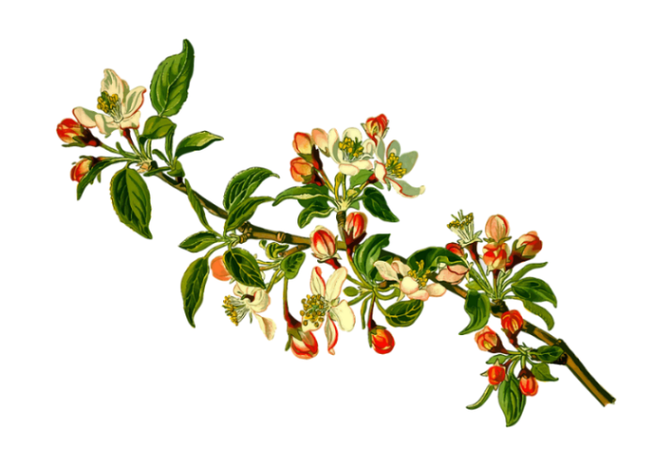

**Join us in showcasing a variety of Cars and Bikes! Come and see the display at The Corner Block on Tallong Apple Day 5th May 2019.**

Competition will be judged on Tallong Apple Day with prizes given to **Best Entry**, **Runner Up** and **People’s Choice** for both Car and Bike. All entries will receive a ribbon and go into the lucky draw. All place winners will receive a trophy and ribbon. People’s Choice will receive hampers. All cars and bikes are displayed on Tallong Apple Day.

**All** exhibitors must register their entry **by 1st May 2019** to email [tallongappledayfestival@gmail.com](mailto:tallongappledayfestival@gmail.com).

**All** cars must be checked in to: Marshalls at Corner Block-Follow signs enter off Highland Way into Memorial Drive, by 8:30am.   
Cars **must remain on site** until after 2pm on Tallong Apple Day 5th May.

Winners announced at 1pm on Main Stage.

[due to safety regulations] 

For more information, queries and entry forms please visit our website or contact us via email at [tallongappledayfestival@gmail.com](mailto:tallongappledayfestival@gmail.com)