An invitation to take part in the
Granny Apple Art Competition
Open to Infants and Pre-Schoolers
Sunday 6th May 2018
Create a Banner!
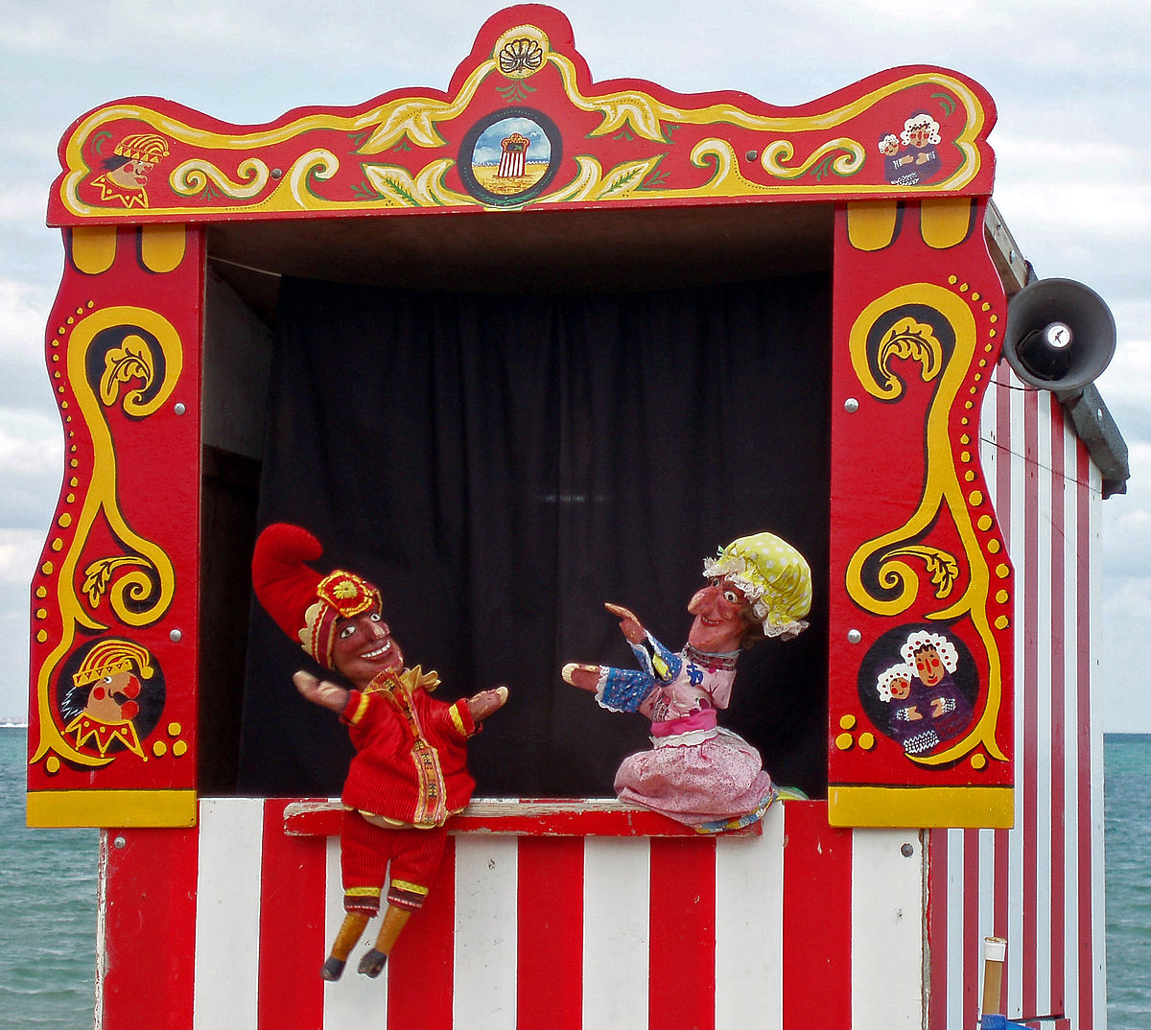 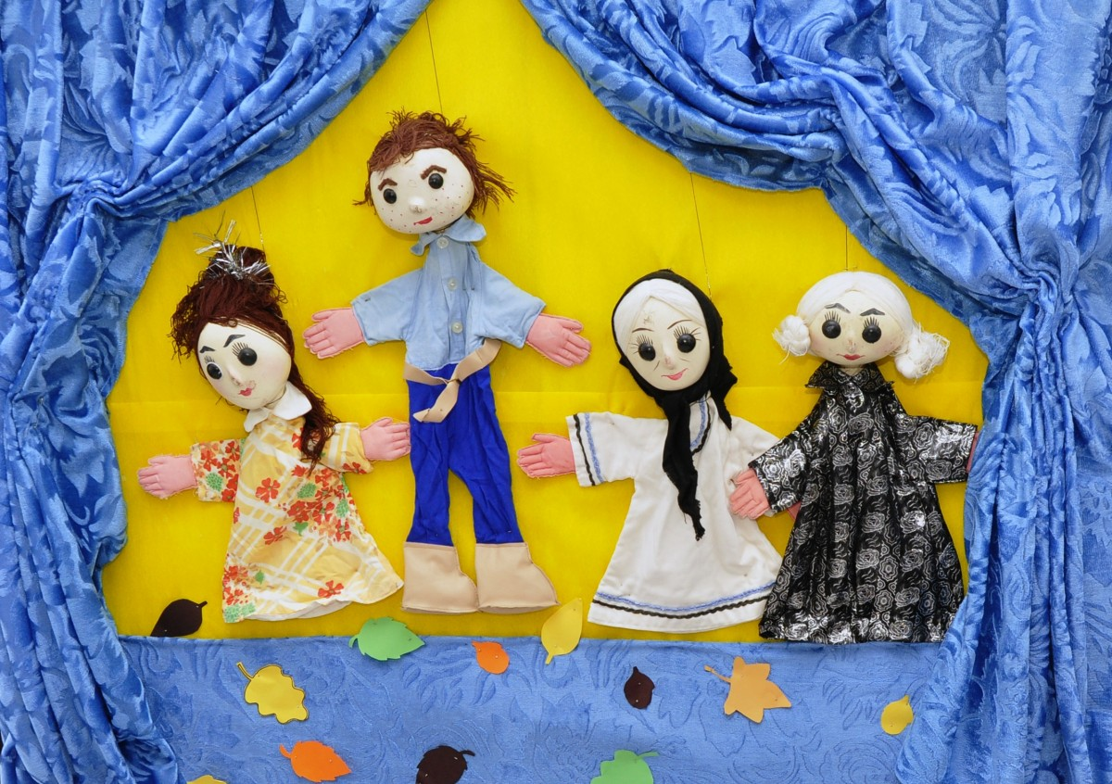
All enquiries Christine Wursten 0418648610 or wursten@bigpond.com _

